- Create a namespace dev-environment and apply a resource-based quota that restricts the number of pods to 3 and services to 2.
Step 1: Create the Namespace
kubectl create namespace dev-environment
You can verify:
kubectl get namespaces
Step 2: Create a ResourceQuota YAML File
Create a file named resource-quota.yaml with the following content:
apiVersion: v1
kind: ResourceQuota
metadata:
name: dev-quota
namespace: dev-environment
spec:
hard:
pods: "3"
services: "2"
Step 3: Apply the ResourceQuota
kubectl apply -f resource-quota.yaml
Step 4: Verify the Quota
kubectl get resourcequota -n dev-environment
To see detailed usage:
kubectl describe resourcequota dev-quota -n dev-environment
Expected Output Example
Name: dev-quota
Namespace: dev-environment
Resource Used Hard
-------- ---- ----
pods 0 3
services 0 2
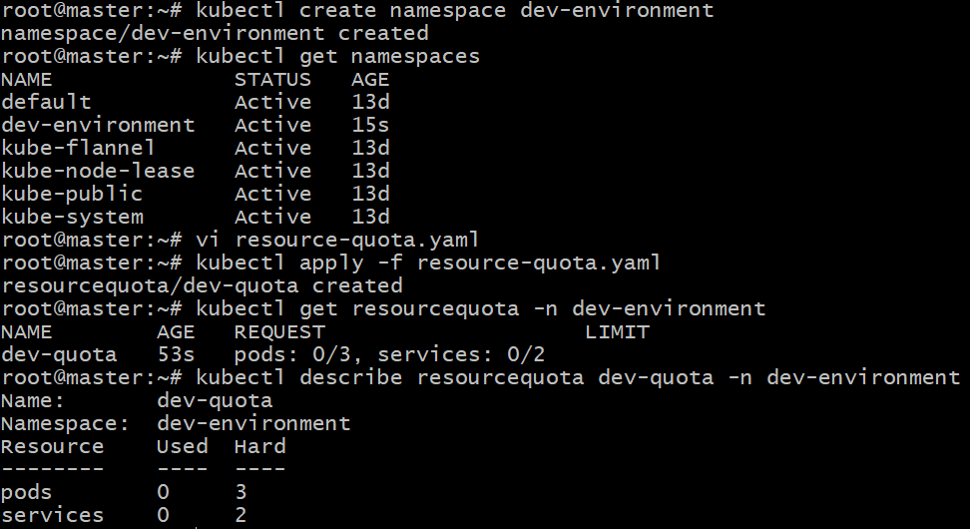
- Create a pod in the prod-environment namespace with 0.2 CPU and 200Mi memory requests, and 0.5 CPU and 500Mi memory limits.
Step 1: Create the Namespace
If not already created:
kubectl create namespace prod-environment
Step 2: Create the Pod YAML File
Create a file named prod-pod.yaml with the following content:
apiVersion: v1
kind: Pod
metadata:
name: resource-pod
namespace: prod-environment
spec:
containers:
- name: nginx
image: nginx:latest
resources:
requests:
cpu: "0.2"
memory: "200Mi"
limits:
cpu: "0.5"
memory: "500Mi"
Step 3: Apply the Pod
kubectl apply -f prod-pod.yaml
Step 4: Verify the Pod and Resource Allocation
Check if the pod is running:
kubectl get pods -n prod-environment
Then describe it to confirm resources:
kubectl describe pod resource-pod -n prod-environment
Look under the “Containers → Resources” section — you should see:
Limits:
cpu: 500m
memory: 500Mi
Requests:
cpu: 200m
memory: 200Mi
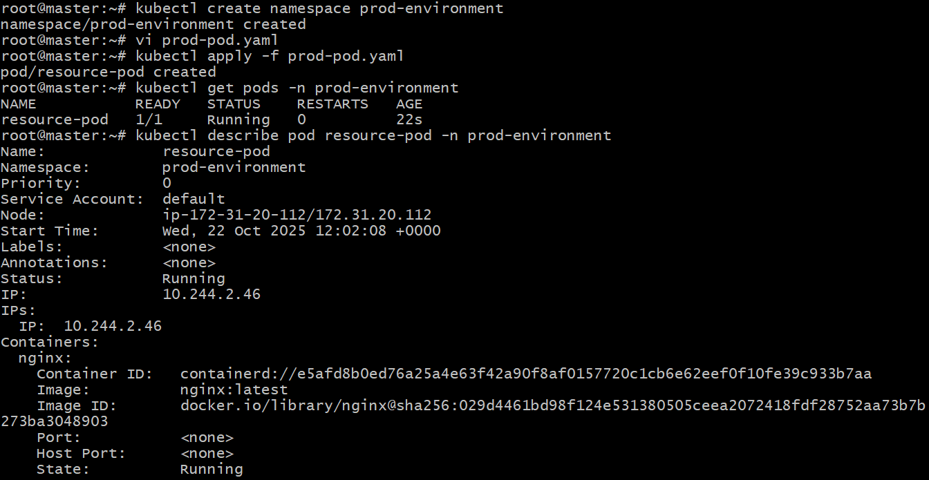
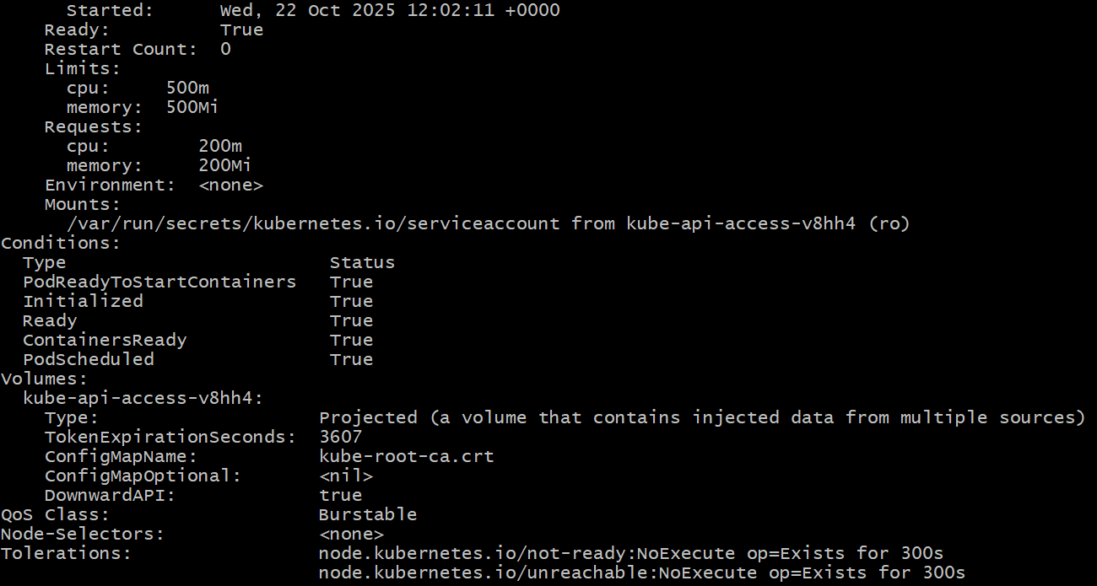
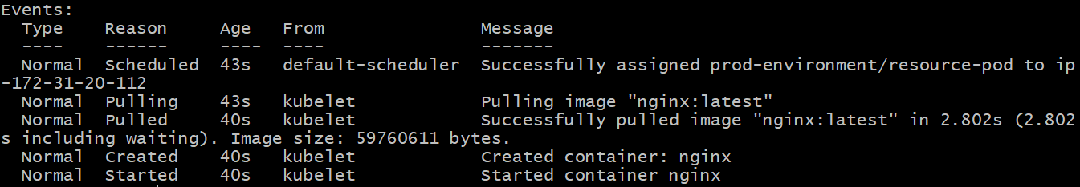
- In the staging-environment namespace, set a Limit Range that assigns default CPU and memory limits (300m CPU, 600Mi memory) and applies a minimum and maximum CPU.
step 1: Create the Namespace
If the namespace doesn’t exist yet:
kubectl create namespace staging-environment
Step 2: Create the LimitRange YAML File
Create a file named limitrange.yaml with the following content:
apiVersion: v1
kind: LimitRange
metadata:
name: staging-limitrange
namespace: staging-environment
spec:
limits:
- default:
cpu: 300m
memory: 600Mi
defaultRequest:
cpu: 200m
memory: 300Mi
max:
cpu: 1
memory: 1Gi
min:
cpu: 100m
memory: 200Mi
type: Container
Step 3: Apply the LimitRange
kubectl apply -f limitrange.yaml
Step 4: Verify the LimitRange
kubectl get limitrange -n staging-environment
To view details:
kubectl describe limitrange staging-limitrange -n staging-environment
Expected Output Example:
Name: staging-limitrange
Namespace: staging-environment
Type Resource Min Max Default Request Default Limit Max Limit/Request Ratio
---- -------- --- --- --------------- -------------- ----------------------
Container cpu 100m 1 200m 300m
Container memory 200Mi 1Gi 300Mi 600Mi
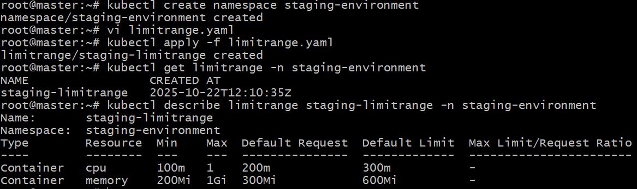
- Create a pod and a Node Port service in the default namespace, then create another pod in the test namespace and communicate between them using Service DNS.
Step 1: Create the test Namespace
kubectl create namespace test
Step 2: Create a Pod and NodePort Service in the Default Namespace
Create a YAML file named app-default.yaml:
apiVersion: v1
kind: Pod
metadata:
name: nginx-pod
labels:
app: nginx
spec:
containers:
- name: nginx
image: nginx
ports:
- containerPort: 80
---
apiVersion: v1
kind: Service
metadata:
name: nginx-service
spec:
type: NodePort
selector:
app: nginx
ports:
- port: 80
targetPort: 80
nodePort: 30080
Apply it:
kubectl apply -f app-default.yaml
Verify:
kubectl get pods,svc

Expected output:
NAME READY STATUS RESTARTS AGE
pod/nginx-pod 1/1 Running 0 1m
NAME TYPE CLUSTER-IP EXTERNAL-IP PORT(S) AGE
service/nginx-service NodePort 10.96.232.84 <none> 80:30080/TCP 1m
Step 3: Create Another Pod in the Test Namespace
Create client-pod.yaml:
apiVersion: v1
kind: Pod
metadata:
name: curl-client
namespace: test
spec:
containers:
- name: curl
image: curlimages/curl:latest
command: ["sleep", "3600"]
Apply:
kubectl apply -f client-pod.yaml
Check:
kubectl get pods -n test
Step 4: Access the Default Namespace Service from the Test Namespace
Use the Service’s DNS name format:
<service-name>.<namespace>.svc.cluster.local
In this case:
nginx-service.default.svc.cluster.local
Now, exec into the client pod:
kubectl exec -it curl-client -n test -- sh
Inside the pod, run:
curl nginx-service.default.svc.cluster.local
You should see the default NGINX welcome page HTML output, confirming successful inter-namespace communication 🎉
Step 5: (Optional) Verify DNS Resolution
Inside the client pod:
nslookup nginx-service.default.svc.cluster.local
You’ll see the ClusterIP of the service (like 10.x.x.x).
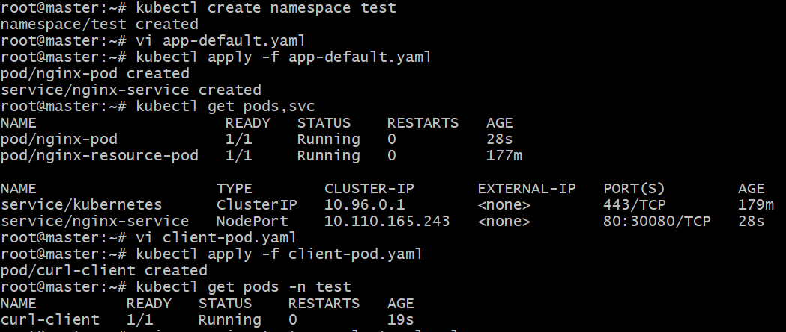
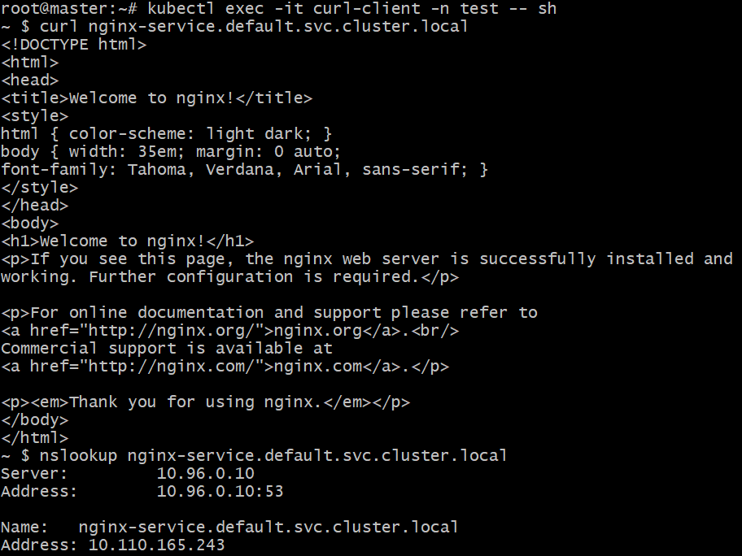
- Apply a Limit Range with a max limit/request ratio of 2 for memory in the performance-environment namespace, and test by creating a pod with mismatched resource requests and limits.
Step 1: Create the Namespace
kubectl create namespace performance-environment
Step 2: Create a LimitRange with Max Limit/Request Ratio
Create a YAML file named limit-range-performance.yaml:
apiVersion: v1
kind: LimitRange
metadata:
name: perf-limitrange
namespace: performance-environment
spec:
limits:
- type: Container
maxLimitRequestRatio:
memory: 2
Explanation:
The maxLimitRequestRatio enforces that
memory limit ≤ 2 × memory request.
If a Pod specifies a higher ratio (e.g., request 100Mi but limit 300Mi), it will fail to create.
Step 3: Apply the LimitRange
kubectl apply -f limit-range-performance.yaml
Verify:
kubectl describe limitrange perf-limitrange -n performance-environment
You’ll see:
Type Resource Limit/Request Ratio
---- -------- -----------------------
Container memory 2
Step 4: Test with a Violating Pod
Now, create a Pod that breaks this rule (limit/request ratio = 3).
Create invalid-pod.yaml:
apiVersion: v1
kind: Pod
metadata:
name: invalid-pod
namespace: performance-environment
spec:
containers:
- name: nginx
image: nginx
resources:
requests:
memory: "100Mi"
limits:
memory: "300Mi"
Step 5: Apply and Observe
kubectl apply -f invalid-pod.yaml
You’ll get an error similar to:
Error from server (Forbidden): error when creating "invalid-pod.yaml":
pods "invalid-pod" is forbidden: maximum memory limit to request ratio per Container is 2, but provided ratio is 3.000000
That means the LimitRange policy is working correctly.
